Slepá mapa POLOHA EURÓPY
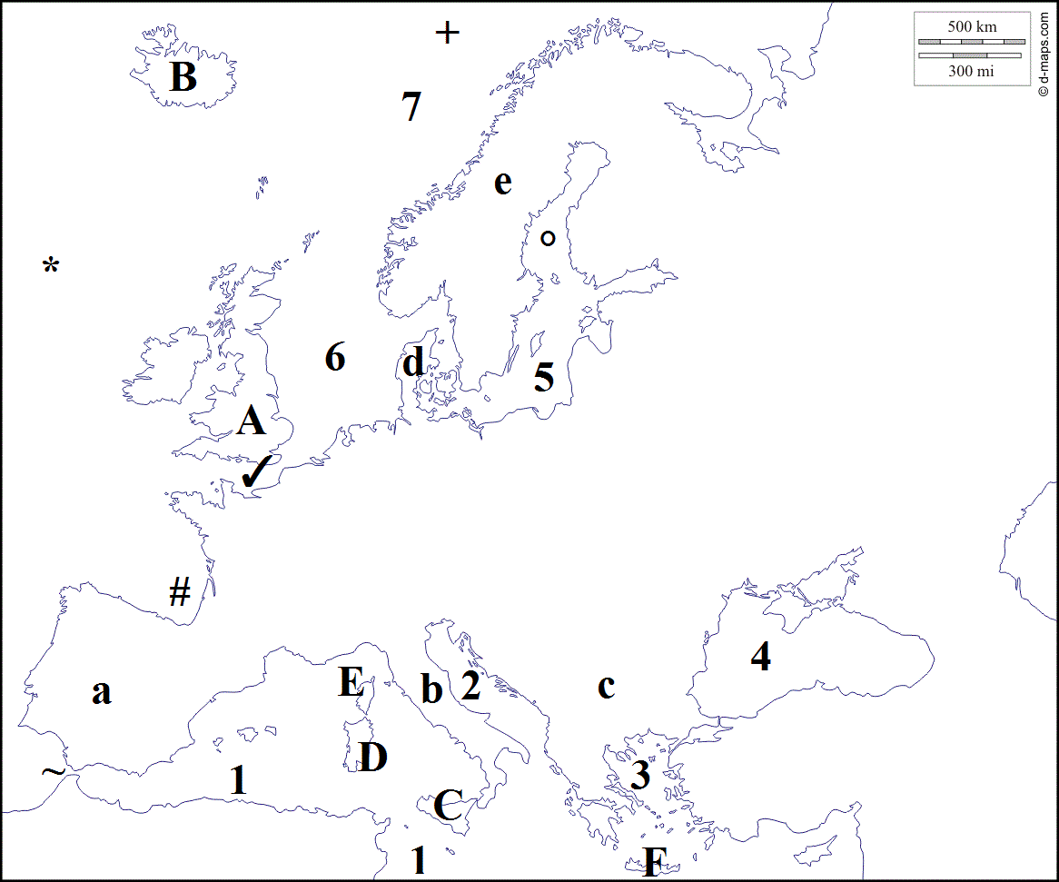
Oceány:
* _____________________
+ _____________________
Moria:
- _____________________
- _____________________
- _____________________
- _____________________
- _____________________
- _____________________
- _____________________
Polostrovy:
- _____________________
- _____________________
- _____________________
- _____________________
- _____________________
Ostrovy:
- _____________________
- _____________________
- _____________________
- _____________________
- _____________________
- _____________________
Prielivy:
~ _____________________
✓ _____________________

Zálivy: # _____________________ ° _____________________

